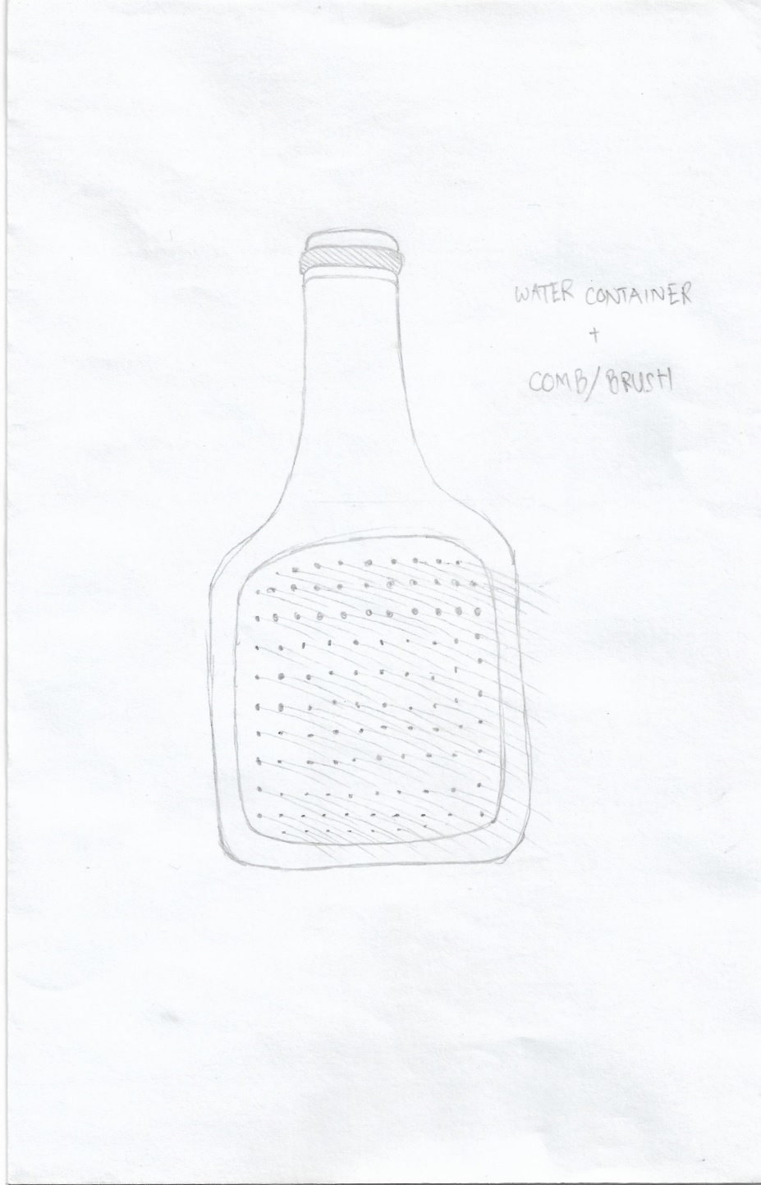

**Compact Versatility**

1. Usability
2. Flexibility
3. Applicability